

## PHYSICS

## YEAR 11

## 2A/2B

**2014**

**Name:_______________________________**

**TIME allowed for this paper**:

Reading time before commencing work 10 minutes

Working time for paper 2.5 hours

# *MATERIALS REQUIRED/RECOMMENDED FOR THIS PAPER*

**To be provided by the supervisor:**

* This Question/Answer Booklet; Formula and Constants sheet

**To be provided by the candidate:**

* Standard items: pens, pencils, eraser or correction fluid, ruler, highlighter.
* Special items: Calculators satisfying the conditions set by the Curriculum Council for this subject.

# *IMPORTANT NOTE TO CANDIDATES*

No other items may be taken into the examination room. It is **your** responsibility to ensure that you do not have any unauthorised notes or other items of a non-personal nature in the examination room. If you have any unauthorised material with you, hand it to the supervisor **before** reading any further.

All calculations are to be set out in detail. Marks may be awarded for correct equations and clear setting out, even if you cannot complete the calculation. Express **numerical answers** to two (2) or three (3) significant figures and include units where appropriate. Express **estimates** to one (1) or two (2) significant figures, and state any assumptions clearly.

**STRUCTURE OF THE PAPER**

|  |  |  |  |  |  |
| --- | --- | --- | --- | --- | --- |
| Section | No. of  Questions | No. of questions  to be attempted | Suggested working time  (minutes) | Marks available | Proportion of  exam total |
| 1: Short Answers | 13 | ALL | 55 | 54 | 36% |
| 2: Problem Solving | 8 | ALL | 80 | 80 | 53% |
| 3: Comprehension and  Interpretation | 1 | ALL | 15 | 16 | 11% |

**INSTRUCTIONS TO CANDIDATES**

Write your answers in the spaces provided beneath each question. The value of each question (out of 150) is shown following each question.

The enclosed Physics: Formulae and Constants Sheet may be removed from the booklet and used as required.

Calculators satisfying conditions set by the School Curriculum and Standards Authority may be used to evaluate numerical answers.

Answers to questions involving calculations should be evaluated and given in decimal form. Final answers should be given up to three significant figures and include appropriate units where appropriate. Despite an incorrect final result, credit may be obtained for method and working, providing these are clearly and legibly set out.

Questions containing specific instructions to **show working** should be answered with a complete, logical, clear sequence of reasoning showing how the final answer was arrived at; correct answers which do not show working will not be awarded full marks.

Questions containing the instruction "**ESTIMATE**" may give insufficient numerical data for their solution. Students should provide appropriate figures to enable an approximate solution to be obtained.

**Section 1: Short Answers**

Marks allocated: 54 marks out of a total of 150 (36%)

Suggested working time: 55 minutes

Attempt ALL questions in this section. Not all questions attract the same marks.

Answers are to be written in the space below or next to each question.

Question 1 (2 marks)

An announcer on a radio station plays a practical joke on his listeners by announcing; *‘The temperature today will reach a maximum of 40 Kelvin. It will therefore be a great day to cool off at the beach’*. Explain why the statement is not correct.

Question 2 (2 marks)

A bath towel containing 5.00 x 10 2 mL of water at 20 oC is placed in the sun to dry. Calculate the quantity of heat required to evaporate all the water from the towel.

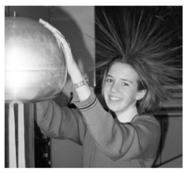

Question 3 (3 marks)

The photo opposite shows a girl standing on an insulated mat and holding on to a Van de Graaf generator that is supplying a very large electrical charge to her body. Explain why her hair is the way it is.

Question 4 (6 marks)

A ride at Adventure World involves a roller coaster being hauled to a point 30.0 m above ground level (point A) and allowed to run down a series of slopes until it finally reaches ground level. The fully laden coaster has a mass of 6.00 tonnes.



(a) The fully laden coaster accelerates from rest down the first slope and reaches a velocity of 23.0 ms-1 at the bottom. If the length of the slope is 33.0 m, calculate the acceleration it experiences running down the slope. (2 marks)

(b) If the roller-coaster is moving horizontally at a velocity of 5.00 kmh-1 when it just passes over the second slope (point B), calculate the percentage loss of energy due to friction and other factors. (4 marks)

Question 5 (4 marks)

A tree lopper cuts a 120.0 kg branch from a tree and it falls 5.00 m to the ground. Assuming the branch is in free fall, calculate:

(a) the speed of the branch when it hit the ground. (2 marks)

(b) the magnitude of the average force exerted on the ground during the impact if the impact time of the branch hitting the ground was 0.300 seconds. (2 marks)

Question 6 (3 marks)

One gram of carbon from a modern wooden spoon is tested and found to give, on average, 0.26 Bq. The half life of radioactive carbon is approximately 5730 years. One gram of carbon is obtained from the tomb of Hemaka in Egypt. Over a one hour period, 468 counts are registered.

(a) How many becquerel does this correspond to? (2 marks)

(b) What date does this suggest for Hemaka’s tomb? (1 mark)

Question 7 (6 marks)



A portable charger can be used to recharge a laptop computer when it is not convenient to connect it to the mains. A typical portable charger can deliver 18.0 V with a current of 2.50 A.

(a) If the device is connected to the laptop for 3.00 hours, how

much charge flows from the charger to the laptop in that

time? (2 marks)

(b) How many electrons are required to produce the charge calculated in (a) above? (2 marks)

(c) How much work is done in moving the charge? (2 marks)

Question 8 (4 marks)

A year 11 student goes for a midday swim in winter and this causes her normal body temperature to fall by 2.0 oC. She comes out of the water and stands with her back to the Sun to try and get warm. If the solar radiation reaching her is 900.0 Wm-2 and her average body specific heat is 3.50 kJ kg-1 K-1, ESTIMATE how long she needs to stand in the sun until her body temperature becomes normal again.

Question 9 (4 marks)

The figure shows two industrial spies sliding an initially stationary 225 kg floor safe a displacement *d* of 8.50 m, straight toward their truck. The horizontal push F1 of Spy 001 is 10.0 N the horizontal pull F2 of Spy 002 is 12.0 N. The magnitudes and directions of these forces do not change as the safe moves, and the floor and safe make frictionless contact.

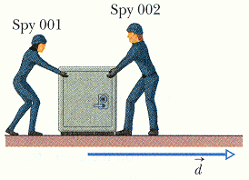

(a) Determine the acceleration of the floor safe? (2 marks)

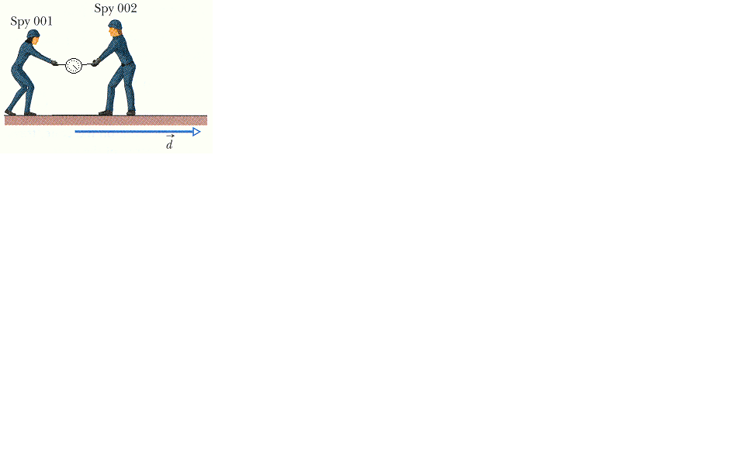

(b) If the safe were replaced by a force measuring scale and the spies maintained their original forces, determine the reading on the scale. (Hint: a vector diagram might help you!) (2 marks)

Question 10 (4 marks)

A researcher, while carrying out a geological survey, measures the amount of the isotope potassium - 40, () in a rock sample. She finds it contains one eighth of the expected amount of this isotope that would be present in a newly formed rock.

The half-life of  is 1.28 x 109 years.

1. Calculate the age of the rock. (2 marks)
2. Explain why it may be difficult to measure the half-life of  in the laboratory. (2 marks)

Question 11 (6 marks)

The radioisotope iodine -131 is used in medicine to treat over-active thyroid glands. It decays into an isotope of xenon (Xe) by beta emission with a half life of 8.1 days. Xenon then emits a gamma ray.

1. Write the two equations that represent these decays.

Equation 1 _________________________________________ (1 mark)

Equation 2 _________________________________________ (1 mark)

(b) In terms of half-life explain why iodine is useful in this application. (2 marks)

(c) A laboratory technician who was handling various radioisotopes in the laboratory was

worried about her health because of exposure to radiation. She knows she is

receiving an absorbed dose of 0.008 mGy from alpha and 0.012 mGy from gamma

each day.

Calculate her dose equivalent over the past 25 days. (2 marks)

Question 12 (4 marks)

(a) Many household electrical appliances are connected to the mains with a cord and ‘3 pin’ plug. One of the pins on the plug is called the ‘earth’. Explain how the ‘earth pin’ helps to prevent users of the appliance from receiving an electric shock if the appliance malfunctions.

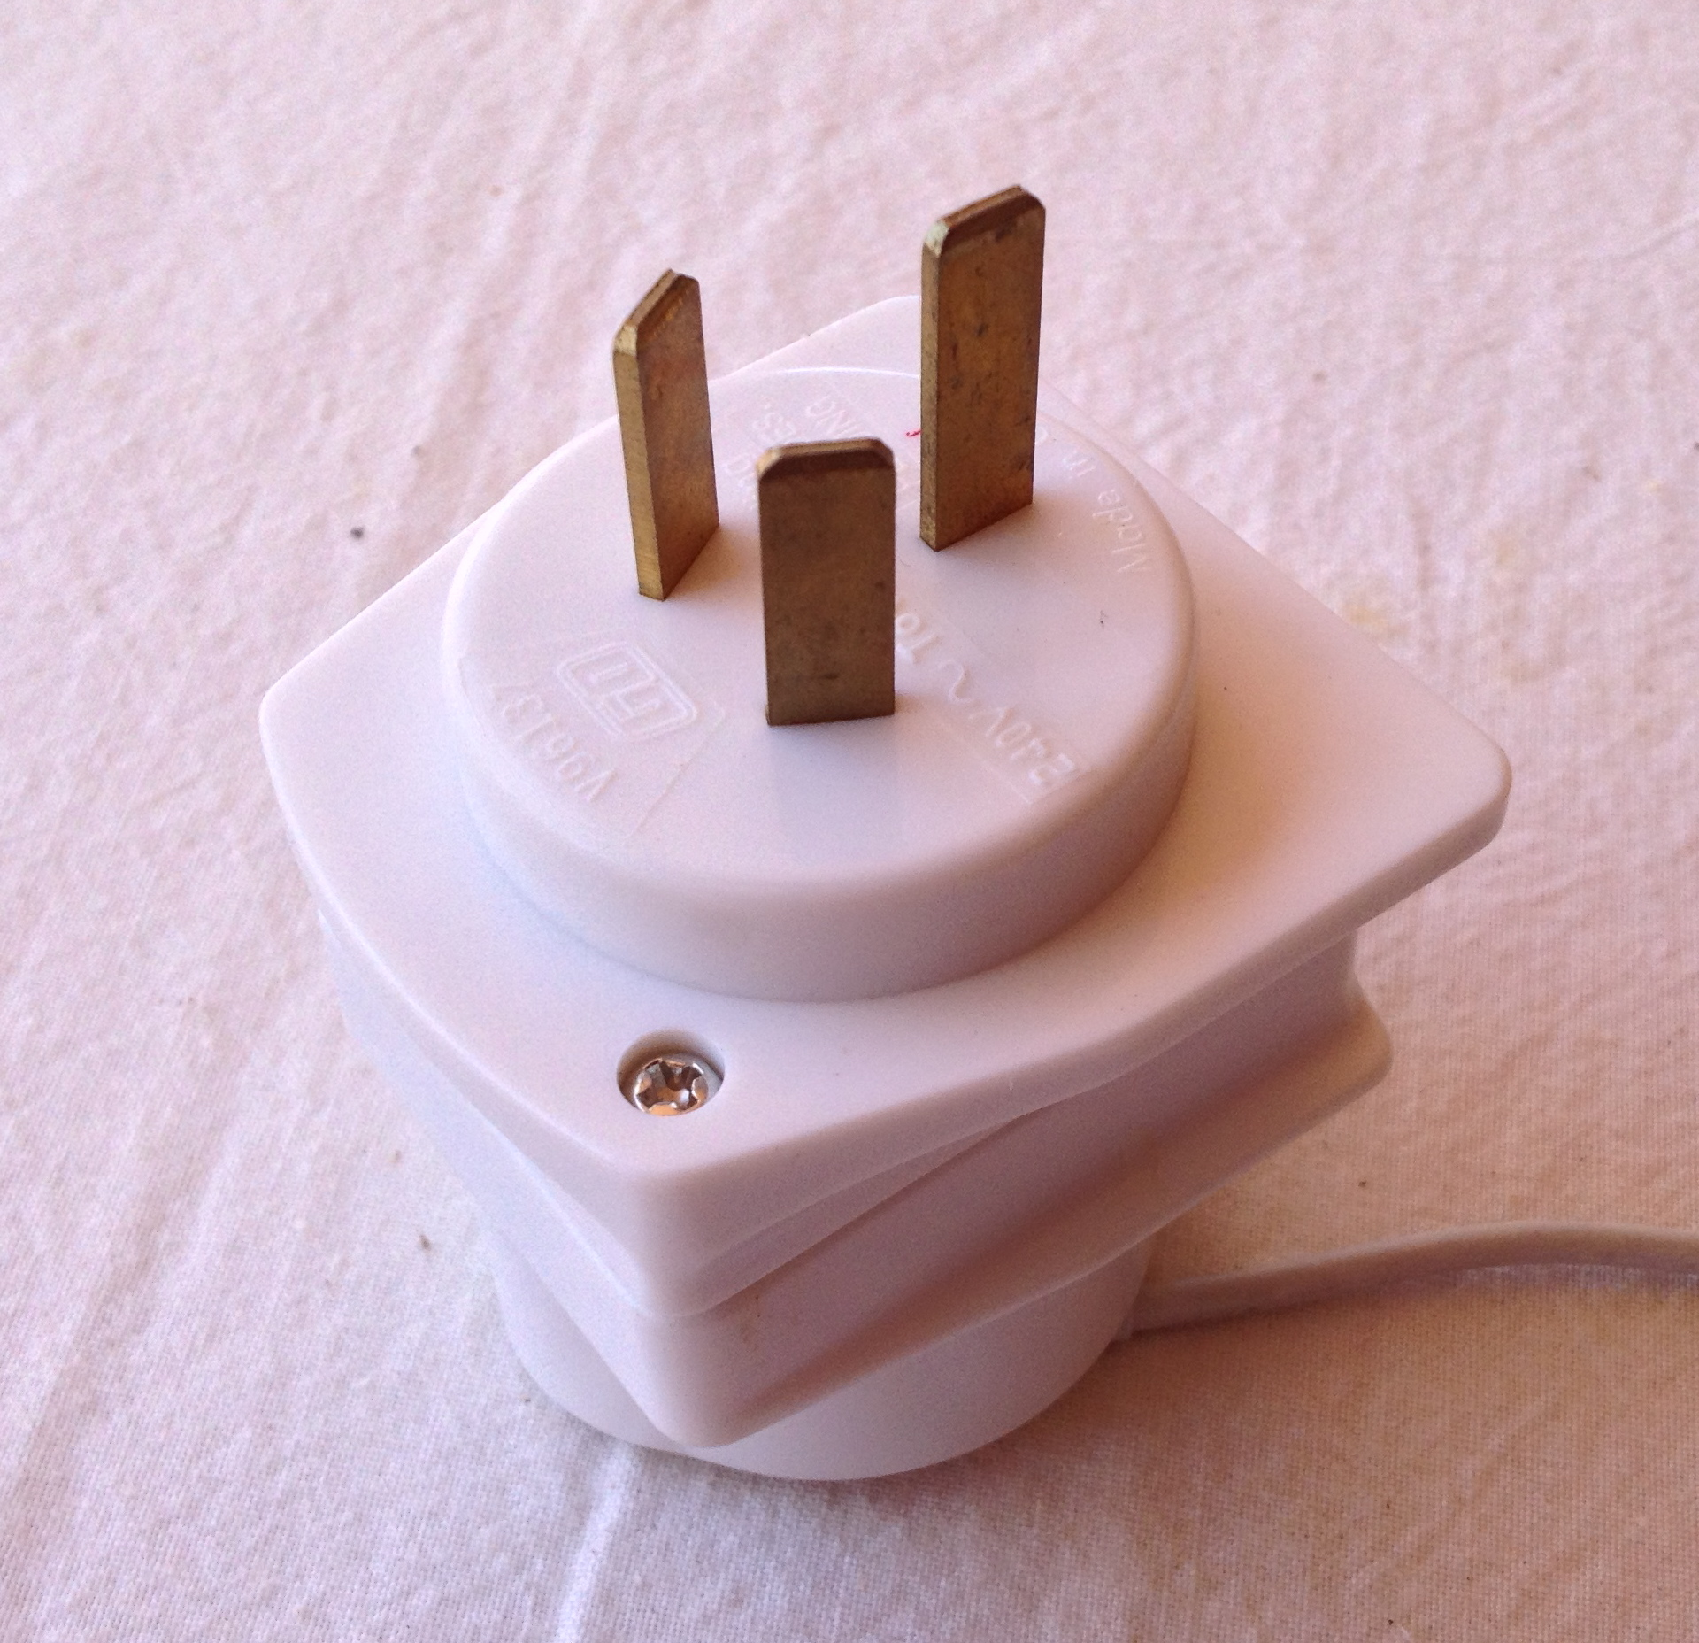

(2 marks)

(b) Other appliances are connected to the mains with a cord and ‘2 pin’ plug. Why is it considered safe to use a ‘2 pin’ plug instead of a ‘3 pin’ plug for these

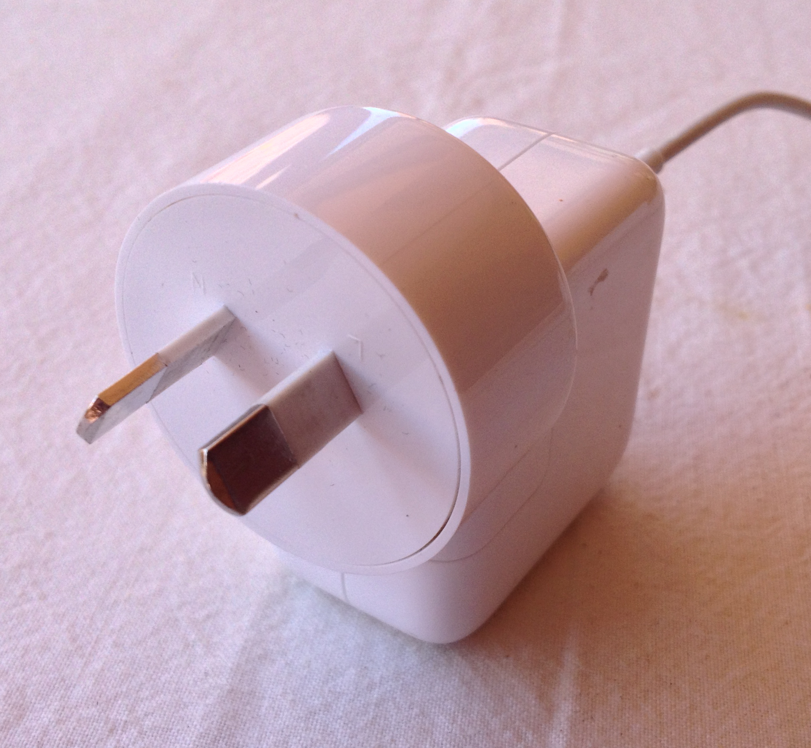

appliances? (2 marks)

Question 13 (6 marks)

A ball is thrown vertically upwards from the top of a 58.0 m tall building. The ball has an initial speed of 15.0 ms-1. (For the following questions assume negligible air resistance).

(a) Calculate the time for the ball to hit the ground. (4 marks)

(b) Calculate the ball’s speed on impact with the ground. (2 marks)

**END OF SECTION 1**

**Section 2: Problem Solving**

Marks allotted: 80 marks out of a total of 150 (53%)

This section contains 8 questions. Suggested working time 80 minutes

Answer the questions in the spaces provided.

Question 14 (9 marks)

An experiment was conducted in which 200.0 g of ice at 0.00 oC was placed into a glass jug. An electric heater with a constant power output of 300 W was used to heat the ice. The transfer of heat from the electric heater to the ice/water was 80% efficient.

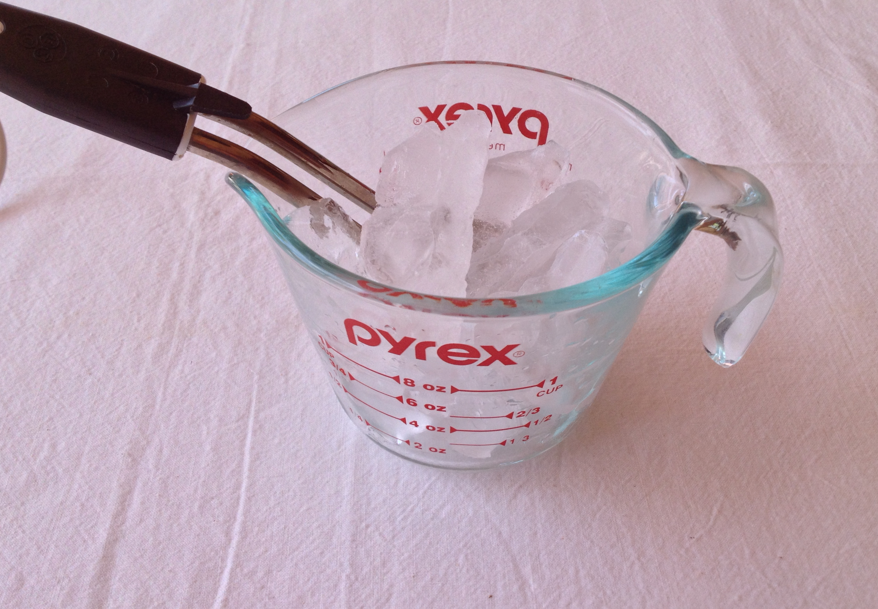

(due to heat lost to the glass jug and air)

(a) Calculate the quantity of heat supplied by the electric

heater to melt the ice (1 mark)

(b) Calculate the time taken to melt the ice. (2 marks)

(c) Calculate the quantity of heat supplied by the electric heater to heat the water to its

boiling point. (2 marks)

(d) Calculate the total time taken to melt the ice and heat the water to its boiling point. (2 marks)

(e) On the graph grid below draw a graph showing temperature (y axis) versus time

(x axis) for heating the ice and water for 20 minutes. (2 marks)



Question 15 (12 marks)

A 50.0 kg student undertakes a science project to show the relationships between force, vertical velocity and vertical acceleration. She enters a lift in a high rise building in the city with a set of bathroom scales. She stands on the scales and observes that the scale reading is 490 N when the lift is stationary.

(a) Her next reading is taken when the lift is moving. The reading is 450 N.

(i) Is the lift moving up or down? (2 marks)

Answer ______________________________________________

(ii) Is the lift accelerating up, accelerating down or moving at constant velocity? (1 mark)

Answer ______________________________________________

(b) Her second reading is taken when the lift is also moving. The reading is 540 N.

(i) Is the lift moving up or down? (2 marks)

Answer _______________________________________________

(ii) Is the lift accelerating up, accelerating down or moving at constant velocity? (1 mark)

Answer ________________________________________________

(c) The third reading is taken when the lift is also moving. The reading is 490 N.

(i) Is the lift moving up or down? (2 marks)

Answer _________________________________________________

(ii) Is the lift accelerating up, accelerating down or moving at constant

velocity? (1 mark)

Answer _________________________________________________

(d) A fourth reading of 400 N is observed by the student when the lift is moving.

Calculate the acceleration of the lift during this observation. (3 marks)

Question 16 (9 marks)

In a factory that manufactures plastic food wrap, the thickness of the plastic is monitored by a thickness recorder. The plastic passes between a beta particle source and a detector as shown in the diagram below. The table shows the readings on the detector (in counts per second) during one production run.



|  |  |  |  |  |  |  |  |  |  |  |
| --- | --- | --- | --- | --- | --- | --- | --- | --- | --- | --- |
| Time interval (min) | 0-2 | 2-4 | 4-6 | 6-8 | 8-10 | 10-12 | 12-14 | 14-16 | 16-18 | 18-20 |
| Counts per second | 89 | 90 | 88 | 89 | 91 | 170 | 172 | 172 | 168 | 169 |

(a) State a probable cause for the reading during the sixth interval to be so different from

the fifth interval? (2 marks)

(b) From what material should the safety housing be made to offer MINIMUM necessary protection for workers working near the source? Explain your answer. (2 marks)

The radioactive decay curve for the beta particle source that was used in the thickness detector is shown below.



(c) Use the graph to **accurately** calculate the half-life of the source. Show construction lines clearly on the graph. (3 marks)

(d) Would this source be suitable to use in the thickness detector? Explain your answer. (2 marks)

Question 17 (8 marks)



A 2.50 kg remote controlled car accelerates uniformly from rest to a speed of 4.50 ms-1 in 3.50 s, then travels at that speed for the next 3.00 s before decelerating to come to rest in a further 2.50 s.

(a) On the graph grid below, represent the

speed versus time of the car. Label the

axes and include scales and units for speed

and time. (2 marks)



(b) Use the graph to calculate the acceleration of the car during the first 3.5 s. (1 mark)

(c) Calculate the force required to accelerate the car from rest. (1 mark)

(d) Calculate the gain in the car’s kinetic energy during the first 3.5 s (2 marks)

(e) Calculate the power of the car’s motor when it is travelling at constant speed.

(2 marks)

Question 18 (10 marks)

A car of mass 1200 kg travelling at 20 ms-1 collides with another car of mass 750 kg travelling in the opposite direction at 15 ms-1. The two cars are locked together during the collision.

(a) Calculate the velocity of the cars after the collision. (3 marks)

(b) Calculate the change in momentum of the smaller car. (2 marks)

(c) After the collision, friction between the road and the cars causes them to come to rest after 1.5 seconds. Calculate the average friction force causing this change in motion. (3 marks)

(d) After the crash it was noted that in both cars the air bags had been deployed. What is an air bag and how does it help to protect the drivers in a crash situation? (2 marks)

Question 19 (13 marks)

To investigate the acceleration of an aircraft on its run to take-off, a number of timers were placed along the runway. The timers were placed at 50m intervals and the aircraft accelerated from rest, 100m from the first timer. The following data was collected:

|  |  |  |  |
| --- | --- | --- | --- |
| Position (m) | Time (s) |  |  |
| 100 | 5.15 |  |  |
| 150 | 6.30 |  |  |
| 200 | 7.25 |  |  |
| 250 | 8.10 |  |  |
| 300 | 8.90 |  |  |
| 350 | 9.60 |  |  |

There is a very well established relationship between s and t.

s = ut + ½ at**2**

(a) Work out how you are going to manipulate the data so that you will get a straight-line graph. (4 marks)

What will you graph on the vertical axis? _________________________

What will you graph on the horizontal axis? _________________________

What will the slope of the line represent? _________________________

What will the vertical intercept represent? _________________________

(b) Manipulate the relevant data and fill whatever columns of the table you need to use.

You need to find the equation of the line of best fit through the manipulated data. Plot the graph and draw your “line of best fit” on the graph grid opposite. (4 marks)

(c) What is the slope of the line of best fit? Write the number and the correct unit.

Show construction lines and calculations on the graph. (2 marks)

(d) What is their experimental value of the acceleration of the car during this experiment? Write the number and the correct unit. (1 mark)



(e) Suppose the distances in the original data were measured to a precision of about ±5% and the times were measured to a precision of about ±2%. Estimate the precision you might claim in the measured acceleration of the aircraft. Show your reasoning and calculations. (2 marks)

Question 20 (8 marks)

A typical nuclear reaction, which takes place in a nuclear reactor, is the fission of U-235 by a neutron to produce Xe-140 and Sr-94 as products, with the release of 2 neutrons and a large quantity of energy.

Data: mass of Xe -140 = 139.90544 u

mass of Sr-94 = 93.906378 u

mass of U-235 = 235.04392 u

mass of neutron = 1.008665 u

(a) Write a nuclear equation to represent this fission reaction (2 marks)

(b) How much energy (in joules) is released by the fission of ONE U-235 nucleus? (3 marks)

(c) The power consumption for Perth is 5.0 x 1018 J per month. If that was to be supplied completely by nuclear fission, calculate the mass of U-235 required per month? (3 marks)

Question 21 (11 marks)

An electrical circuit was set up as shown below. There are two meters, a 9.0 V cell, four resistors and a switch.

The total resistance, Rt of the circuit is 16.0 Ω.

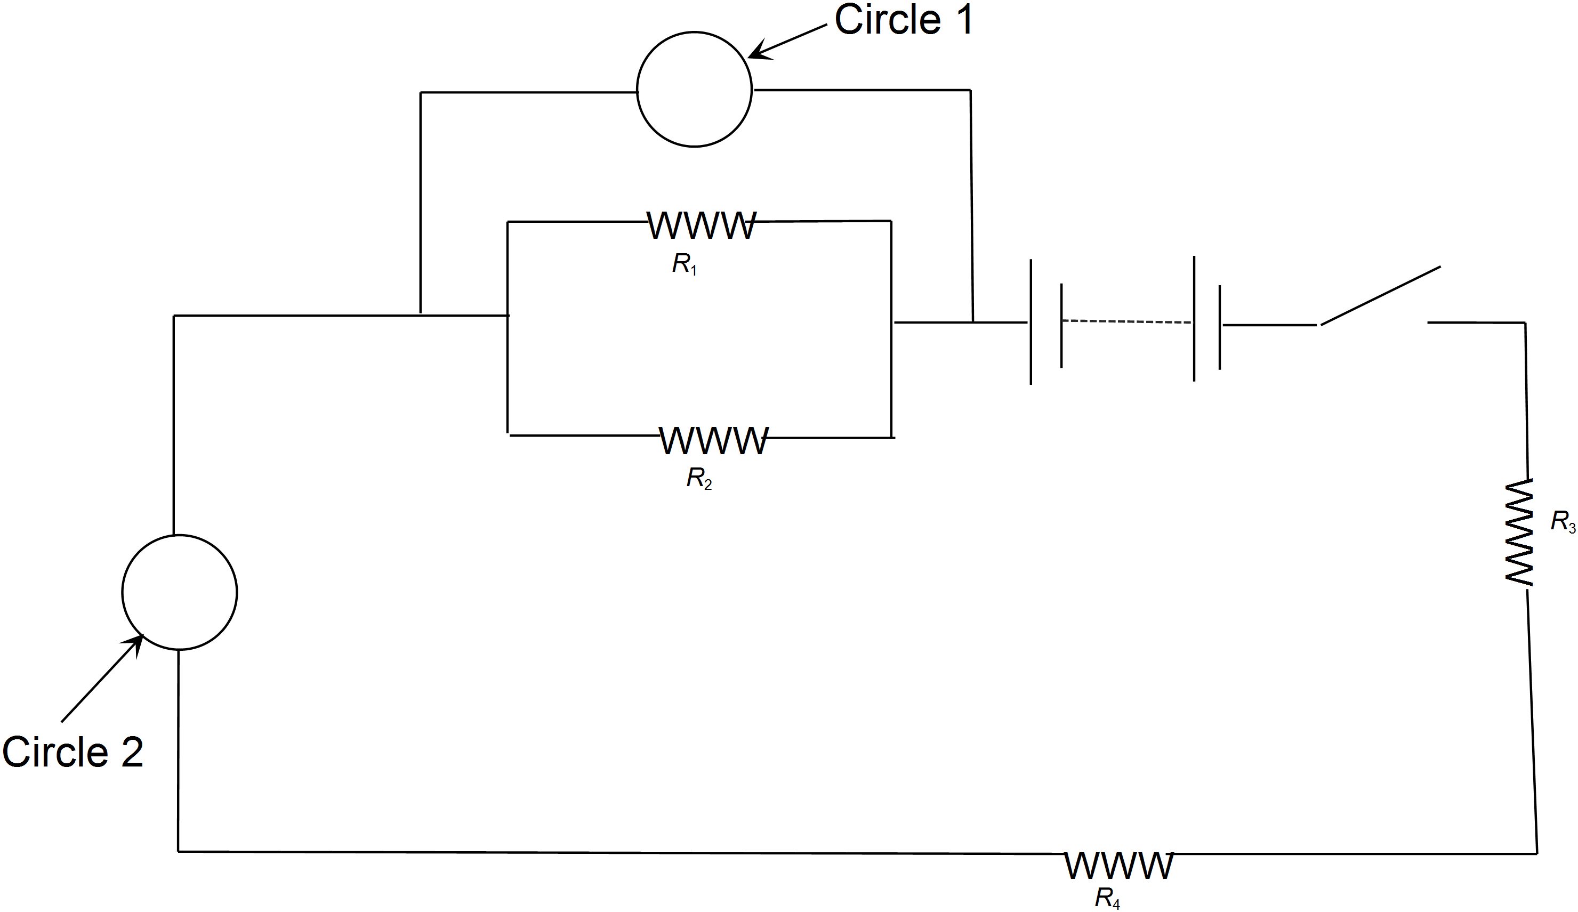

(a) The circles in the circuit indicate where the meters are located. In **circle 1** clearly

write the letter ‘A’ for ammeter or ‘V’ for voltmeter to indicate which meter would be

correctly placed there. Explain why you have chosen to label the meter that way. (2 marks)

(b) In **circle 2** clearly write the letter ‘A’ for ammeter or ‘V’ for voltmeter to indicate

which meter would be correctly placed there. Explain why you have chosen to label

the meter that way. (2 marks)

(c) R2 has a resistance of 8.0 , R4 has a resistance of 2.0  and the total resistance of R1 and R2 is 6.0 . Calculate the resistance of R1. (2 marks)

(d) On the diagram use an arrow to indicate the direction of electron drift in this circuit.

(1 mark)

(e) Calculate the resistance of R3. (2 marks)

(f) Calculate the current flowing through resistor R3.(2 marks)

**END OF SECTION 2**

**Section 3: Comprehension**

(Marks allocated: 16 marks out of 150 (11%). Suggested working time 15 minutes.

This section has one (1) question. You must answer this question. Write your answer in the spaces provided.

When estimating numerical answers, show your working or reasoning clearly. Include appropriate units where appropriate.

You are reminded of the need for clear and concise presentation of answers. Diagrams (sketches), equations and /or numerical results should be included as appropriate.

Question 22 (16 marks)

**SMOKE DETECTORS**

**Householders Ignore Fire Brigade Advice**

**on Smoke Detectors**

Thirty‑two people died and 567 were injured in fires in West Yorkshire last year.

However, only 7% of householders in Yorkshire and Humberside have followed fire brigade advice to fit smoke detectors, which give an early warning of fire and allow time to escape.

A recent Government sponsored survey shows the region joint bottom of all areas in England and Wales. Said Assistant Chief Officer Peter Kneale: "Despite our efforts for the past two years, the area is still well below the national average of 10% in its provision of smoke detectors.”

"We are disappointed to read the statistics when we look back at the efforts we have made to sell the message that smoke detectors save lives."

The survey also shows that pensioners are the most poorly provided for, with only 5% having a smoke detector, despite being one of the groups most at risk.



The diagram opposite shows the construction of one kind of smoke detector.

The weak radioactive source has a long half life and gives out alpha particles. (Americium‑241 is often used.) The alpha particles ionise air molecules in the detector. The ions are attracted to one or other of the electrodes, so a small current flows.

If smoke enters the detector, fewer ions are produced so less current flows. This decrease in current is detected electronically and the alarm is sounded.

Americium-241 has a half life of 432 years. It is used in preference to other radioactive sources

that produce mainly, beta and gamma radiation. The radiation emitted by americium has high

ionizing capabilities and low penetration power. Only about one percent of the emitted radioactive energy of Americium-241 is gamma radiation.

The amount of elemental Americium-241 is small enough to be exempt from the regulations

applied to larger sources. A typical smoke detector contains about 37 kBq of radioactive element

Americium-241 corresponding to about 0.3 µg of the isotope. This provides sufficient ion current to detect smoke, while producing a very low level of radiation outside the device.

The americium-241 in ionizing smoke detectors poses a potential environmental hazard. Disposal regulations and recommendations for smoke detectors vary from country to country.

Questions

(a) Explain what happens to air molecules when they become 'ionised'. (2 marks)

(b) Write a likely nuclear equation for the decay of americium-241 as used in a

smoke detector. (2 marks)

(c) Suggest a reason why fewer ions are produced if smoke enters the detector.

(2 marks)

(d) Explain why a radioactive source that gives out **alpha** particles is used, rather than

one that gives out beta or gamma radiation? (3 marks)

(e) Americium – 241 emits dangerous gamma radiation. Why is this not considered a hazard in the case of smoke detectors? (1 mark)

(f) What is meant by the 'half life' of a radioactive substance? (2 marks)

(g) Explain why the radioactive source used in the detector should have a long half life.

(2 marks)

(h) Some householders might be worried about the presence of a radioactive source in

the detector. What could you say to convince such a person that it is safe?

(2 marks)

**END OF QUESTIONS**